**Project Development Phase**

**Delivery of Sprint - 3**

|  |  |
| --- | --- |
| **Date** | 17 November 2022 |
| **Team Members** | Pavithra L, Priyadharshini B,Nivedhitha V,Rajalakshmi R |
| **Team ID** | PNT2022TMID02444 |
| **Project Name** | AI based discourse for Banking Industry |

**Creating General Query Action**

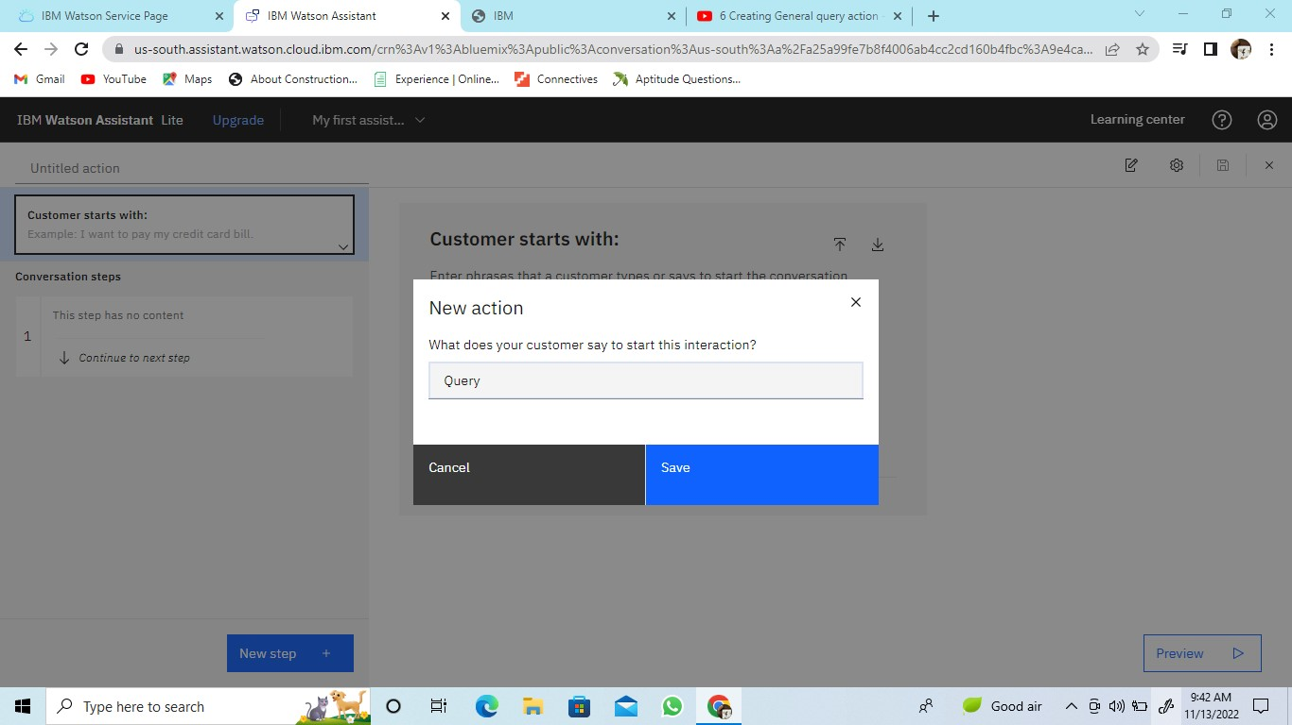

Adding steps in Query action to handle queries regarding Bank working hours, Currency conversion policy, Storage locker facility, CIBIL score, list of all branches, nearest available branch, etc.,

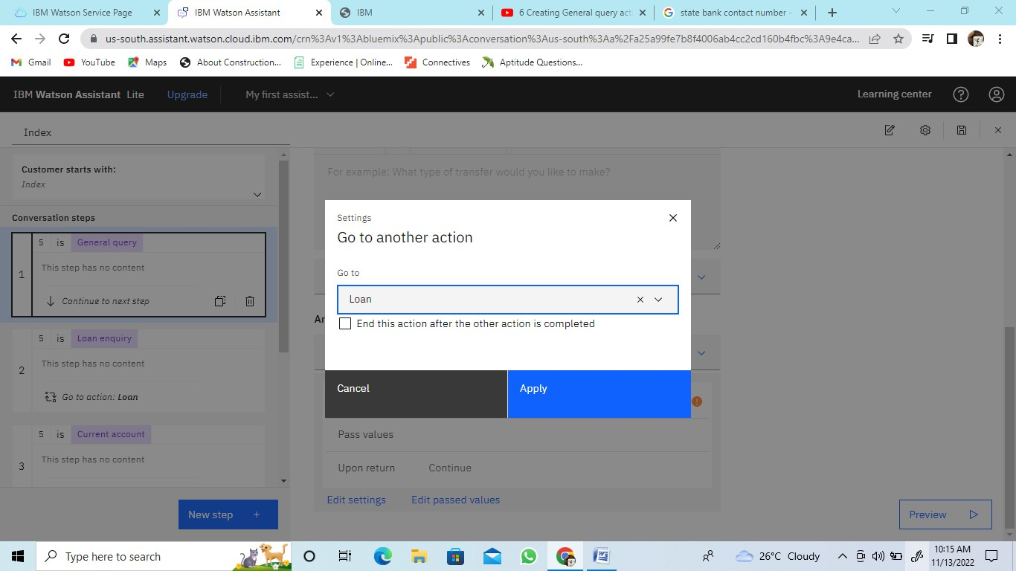

Preview of general query

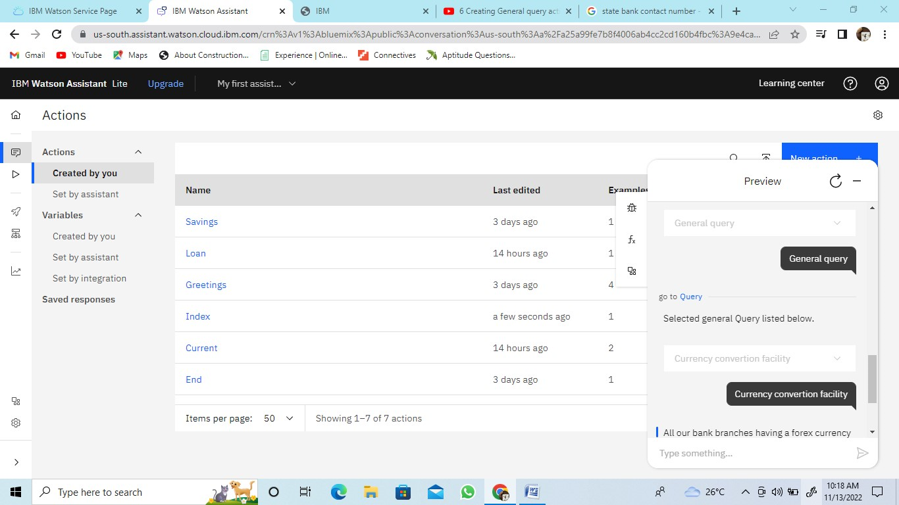

**Creating Net Banking Action**

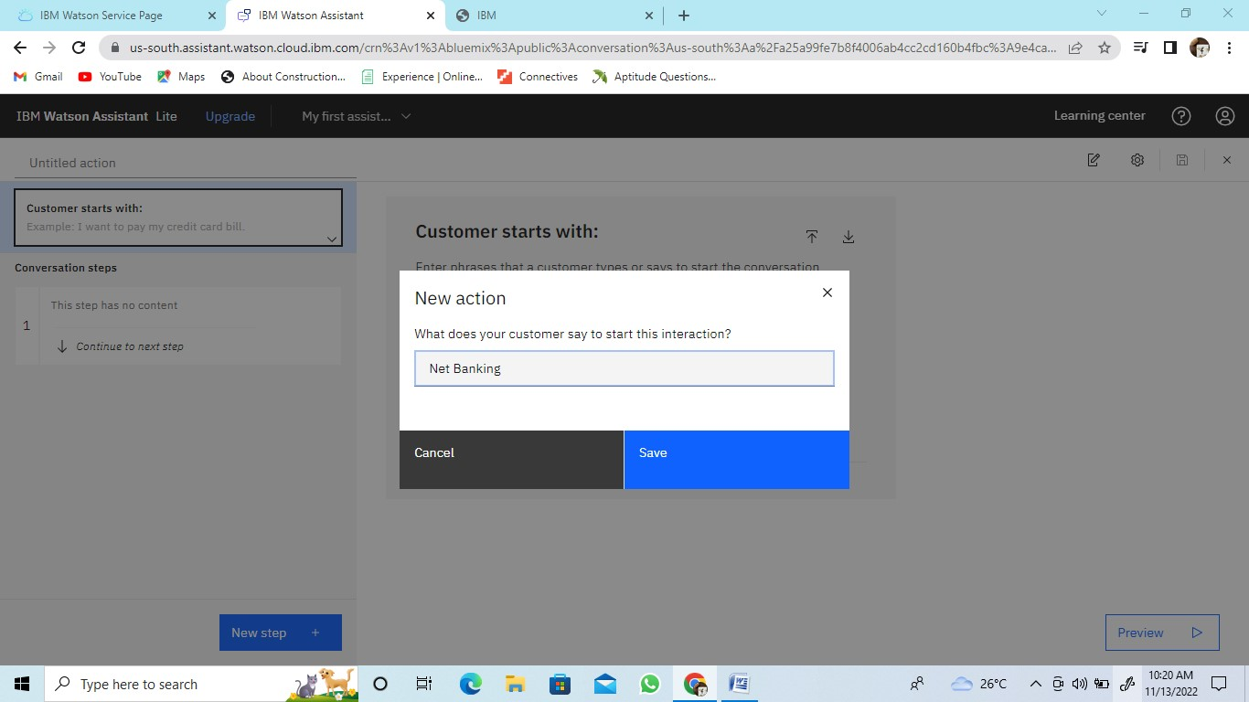

Adding new steps to the existing action

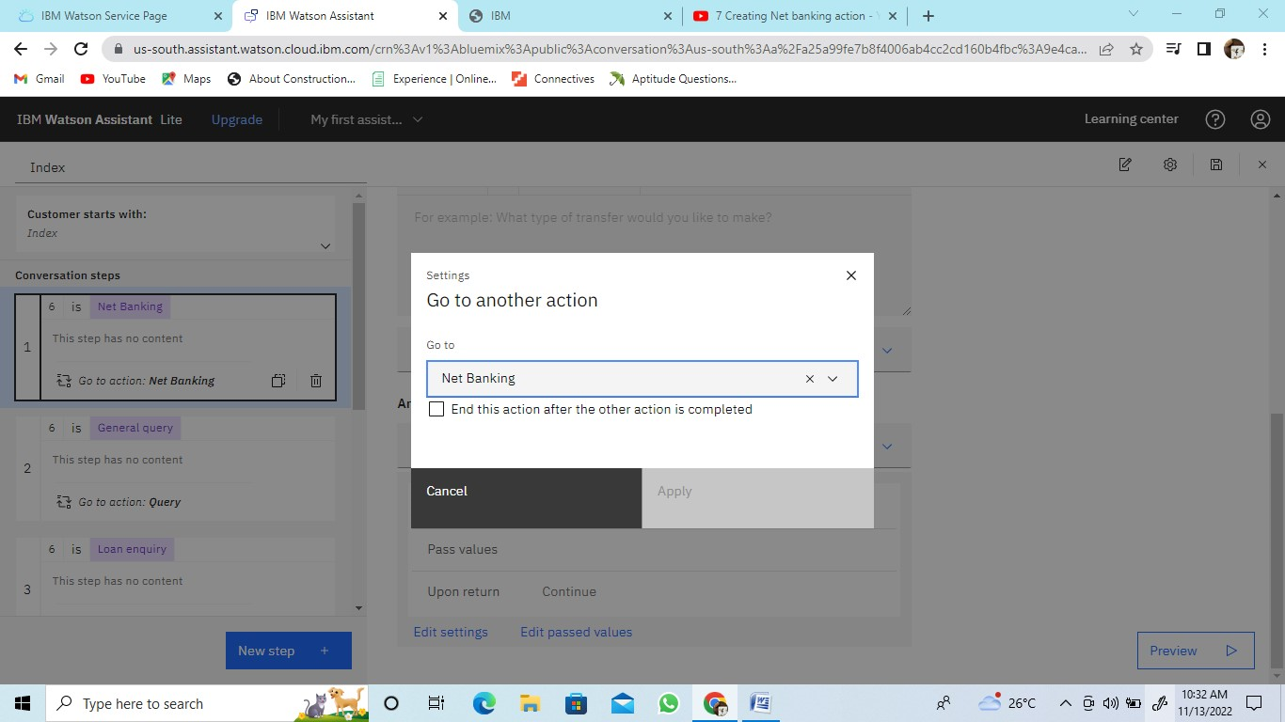

Preview of Net banking action

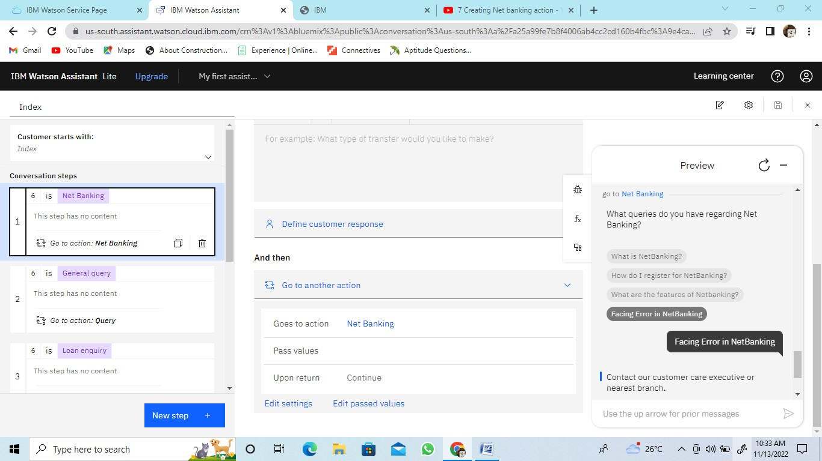

Ending our action by end greetings

